State of Michigan

OBRA Automation suite

Workflow-3

OBRA Reviewer makes determination on Level II

**Workflows with screenshots:**

**Precondition**:

CMH has resubmitted the evaluation after necessary information has been entered in the Assessment forms.

Step 1:

OBRA Staff logs in.

Accessing the Pending Queue

From the Main Dashboard, click the PENDING queue button. The screen below will be displayed.

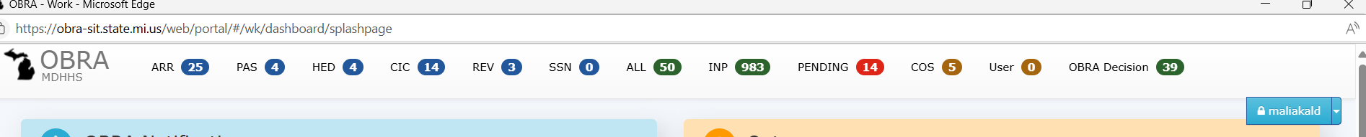

Step 2:

Find the consumer name that was sent to the OBRA staff

Step 3:

Click on the record in the Pending queue.

Land inside “Pending Evaluation” Page.

Step 4: Click on “Close Pending”

Step 5: Land on Evaluation MDHHS Determination screen.

OBRA Staff will make a determination by using the “Determination” and “Diagnosis Category” dropdowns and clicking on “Save” in the MDHHS Determination section. The Re-Evaluation date also can be changed.

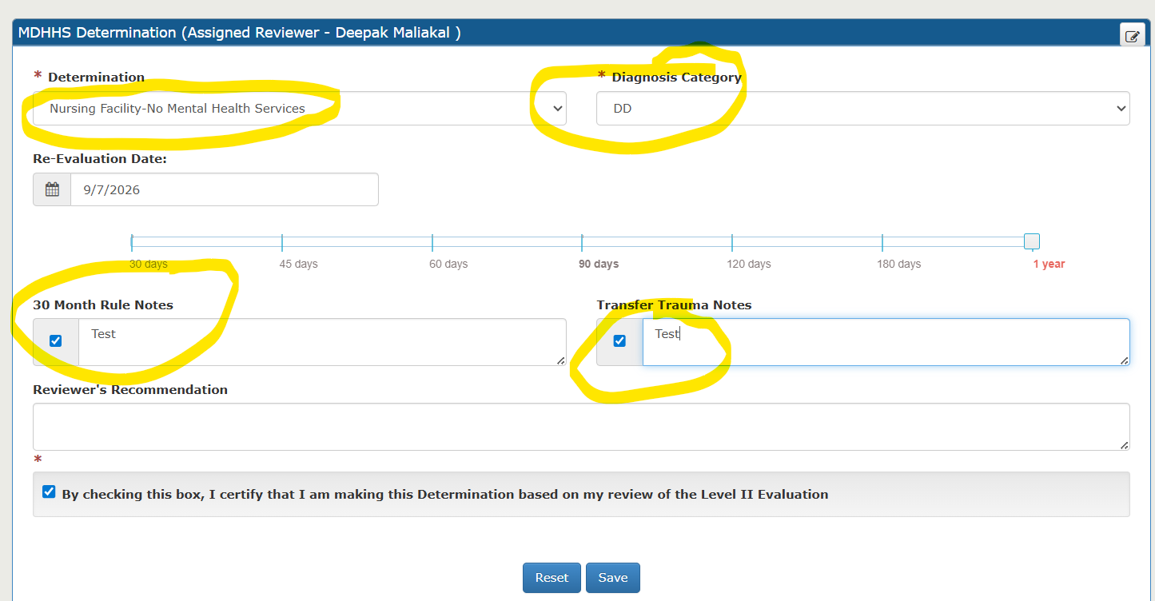

When the determination is made, the status of the Evaluation is changed to “C” denoting “Completed”. This is visible from the screen name, as it says, “Evaluation Detail Completed”

Step 6:

Copy the SSN from the screen.

Step 7:

Navigate to Evaluation Search by clicking OBRA Home page -> Evaluations

Find the Evaluation by using the SSN.

Results displayed below with status C.

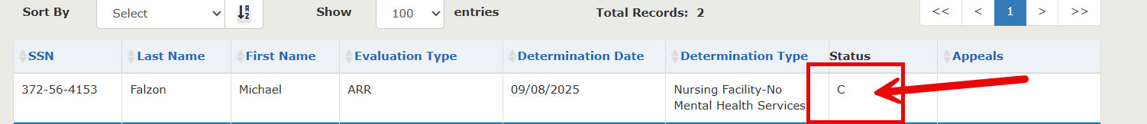

Step 8:

Click on the record.

Land on Evaluation Detail Completed Screen.

Click on the drop down next to the consumer name and then click on “View Previous Evaluations”

Step 9:

Land on Evaluation History page.

